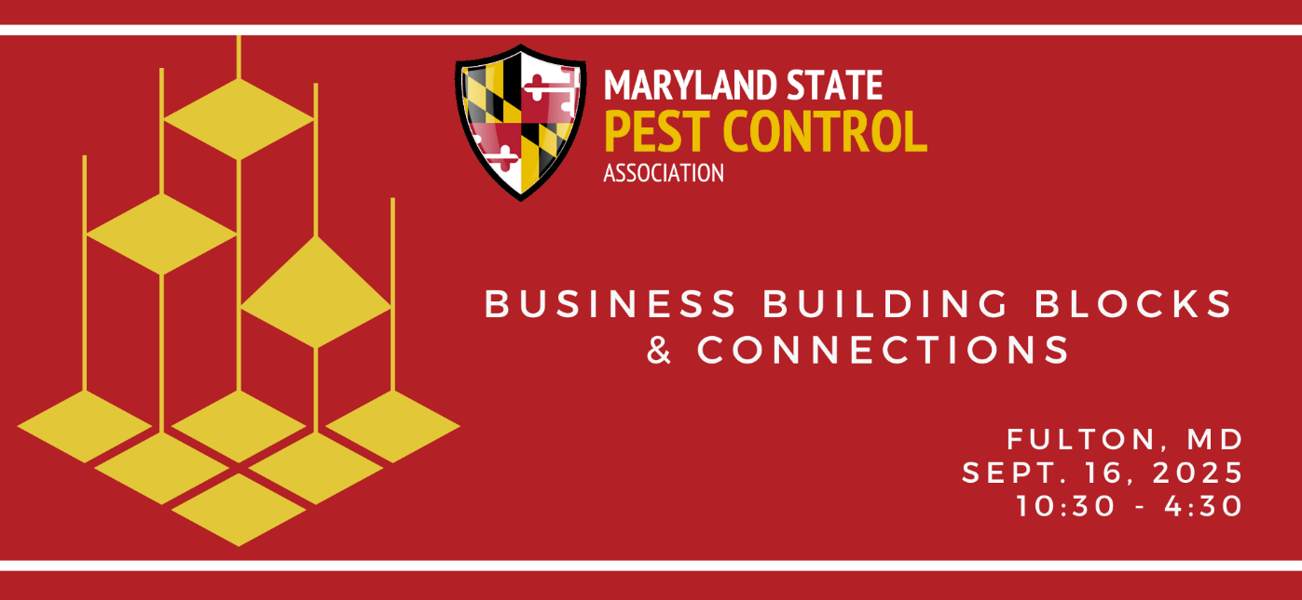

Brett Lieberman, My Pest Pros
Brett Lieberman is the co-owner of My Pest Pros and the current president of the Maryland State Pest Control Association. He also serves on the Virginia Pest Management Association Board and the Central Fairfax Chamber of Commerce. He is active on several NPMA committees. Brett has extensive experience building out My Pest Pros' own AI Voice agent, automations, and working with APIs.

